PROJECT PLANNING PHASE

Prepare Milestone & Activity List

|  |  |
| --- | --- |
| Date | 4 November 2022 |
| Project Name | Smart Fashion Recommender Application |

Milestone

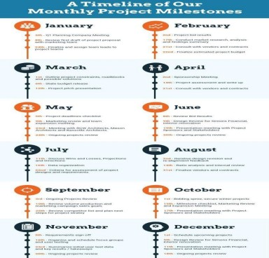

Activity list

